**Introduction**

Pollen in the Poaceae is monoporate (having one pore) and annulate (bearing an annulus, or thickened ring around the pore)(Fig. 1a). Under standard light microscopy, the exine (outer surface) of the pollen grain appears psilate (smooth) or nearly so; at Scanning Electron Microscopy (SEM) magnifications, the exine may appear psilate, or spinulose (spined) or scabrate (elements of any shape less than 1µm in any direction) sculpturing may be evident (Zavada, 1983). The pollen wall bears a thick footlayer, and is tectate-columellate (Fig 1b,c) (Zavada, 1983). The single pore is generally operculate (having a sexineectexine structure covering part of the aperture, and which is isolated from the rest of the sexine) (Fig. 1d).

Intra-exinous channels are often noted in studies of grass pollen micromorphology (Christensen and Horner, 1974) or visible in Transmission Electron Microscopy (TEM) plates without being mentioned by the authors (Liu et al., 2004). Additionally, intra-exinous channels are sometimes listed as a ubiquitous pollen characteristic in the Poaceae (Zavada, 1983; Linder and Ferguson, 1985), and while this appears likely, the claim demands explicit testing. We therefore propose to survey pollen exine structure across the twelve subfamilies of the Poaceae and compare it to the exines in pollen from their close relatives in the Graminid clade; Ecdeiocoleaceae, Joinvilleaceae, and Flagellariaceae using TEM micrographs. This will allow us to test the hypotheses a) Intra-exinous channels are a synapomorphy of the Poaceae; and b) The presence and/or structure of intra-exinous channels is taxonomically significant at the subfamily level in the Poaceae, c) Early-diverging lineages do something else

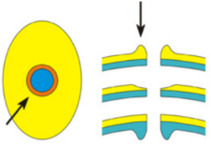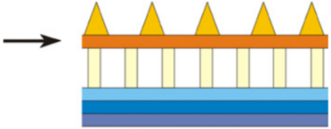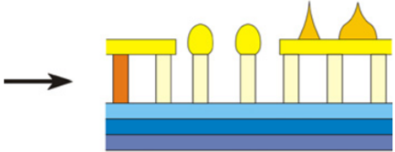 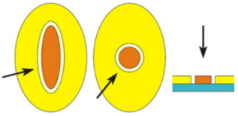

Figure 1a: Annulus, b: Tectum, c: Columellum, d: Operculum **Note: Expand this caption after redrawing and mention footlayer**

*These are taken from Punt et al. 2007’s Glossary of Pollen and Spore Terminology. I plan to redraw them myself and cite it as: Redrawn from Punt et al. (2007)*

**Preliminary results**

Pollen

Intra-exinous channels in Poaceae pollen were first noted in early micrographic studies of pollen exines (G Erdtman, JR Praglowski - Bot. Not, 1959) CHECK THIS

**References**

Christensen, J.E., and H.T. Horner. 1974. Pollen pore development and its spatial orientation during microsporogenesis in the grass Sorghum bicolor. *American Journal of Botany* 61: 604–623.

Linder, H.P., and I.K. Ferguson. 1985. On the pollen morphology and phylogeny of the restionales and poales. *Grana* 24: 65–76.

Liu, Q., N.X. Zhao, and G. Hao. 2004. Pollen morphology of the Chloridoideae (Gramineae). *Grana* 43: 238–248.

Punt, W., P.P. Hoen, S. Blackmore, S. Nilsson, and A. Le Thomas. 2007. Glossary of pollen and spore terminology. *Review of Palaeobotany and Palynology* 143: 1–81.

Zavada, M.S. 1983. Comparative morphology of monocot pollen and evolutionary trends of apertures and wall structures. *The Botanical Review* 49: 331–379.